ECE358 Chapter 3

Transport services and protocols

Logical connection between processes means that as if it appears that these processes are directly connected to each other.

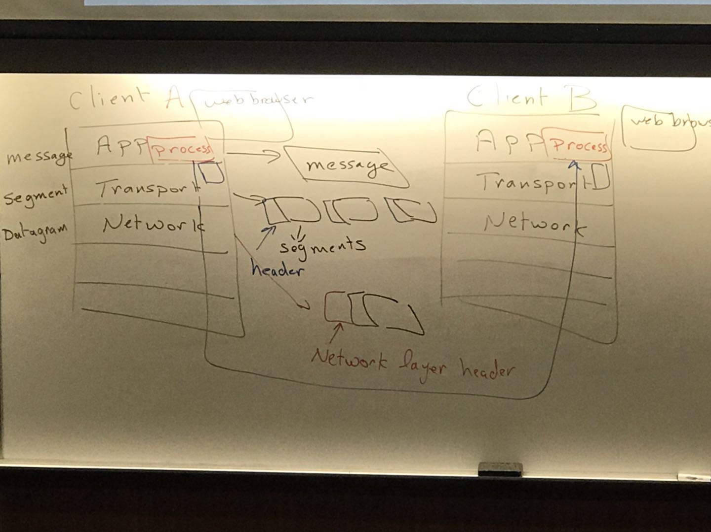

Network provide logical communications between hosts.

The network layer offer “best –effort” service where segments can be received out of order or they can get lost.

UDP -> logical connection between process. Also error check

UDP to do demultiplexing, it checks the destination port number and dest. IP address.

Number of ports: 65535.

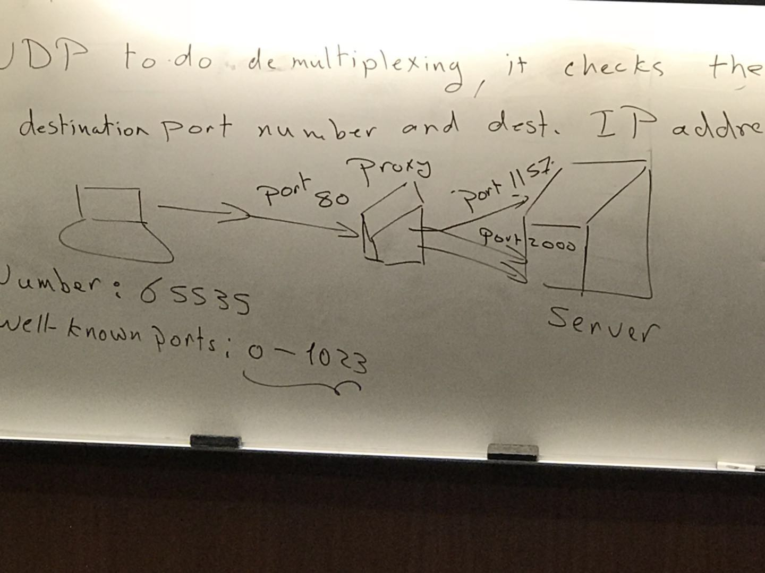

Well-known ports: 0-1023 HTTP80, HTTPS443

DeMUX -> UD-> segment identified by destination, port# and dest.port#

Using TCP-> segment are identified by using 1. Source IP, 2. Source prot, 3. Dest. IP 4. Dest.port

3.3 UDP:segment header

UDP header size is 8 Bytes.

TCP header size is 20 Bytes.